Greater Richmond, Virginia Labor Shed
Businesses in the Richmond, Virginia metro area draw labor from 38 counties in central Virginia – an area with 2.2 million population and a workforce of 1.1 million.
The primary labor shed is the 17 counties in the Richmond MSA, which has 1.3 million population and a workforce of 654,000. The secondary labor shed includes 21 counties with 917,000 population and a workforce of 473,000; at least 500 residents of each of these county’s work in the Richmond MSA.
The region’s population has increased by 9 percent since 2011, adding over 18,500 additional residents annually.
Area | Population 2020 | Civilian Labor Force  2020 Q4
Primary Labor Shed (17 counties) | 1,303,469 | 654,156
Secondary Labor Shed (21 counties) | 916,728 | 472,862
Total Labor Shed (38 counties) | 2,220,197 | 1,124,564
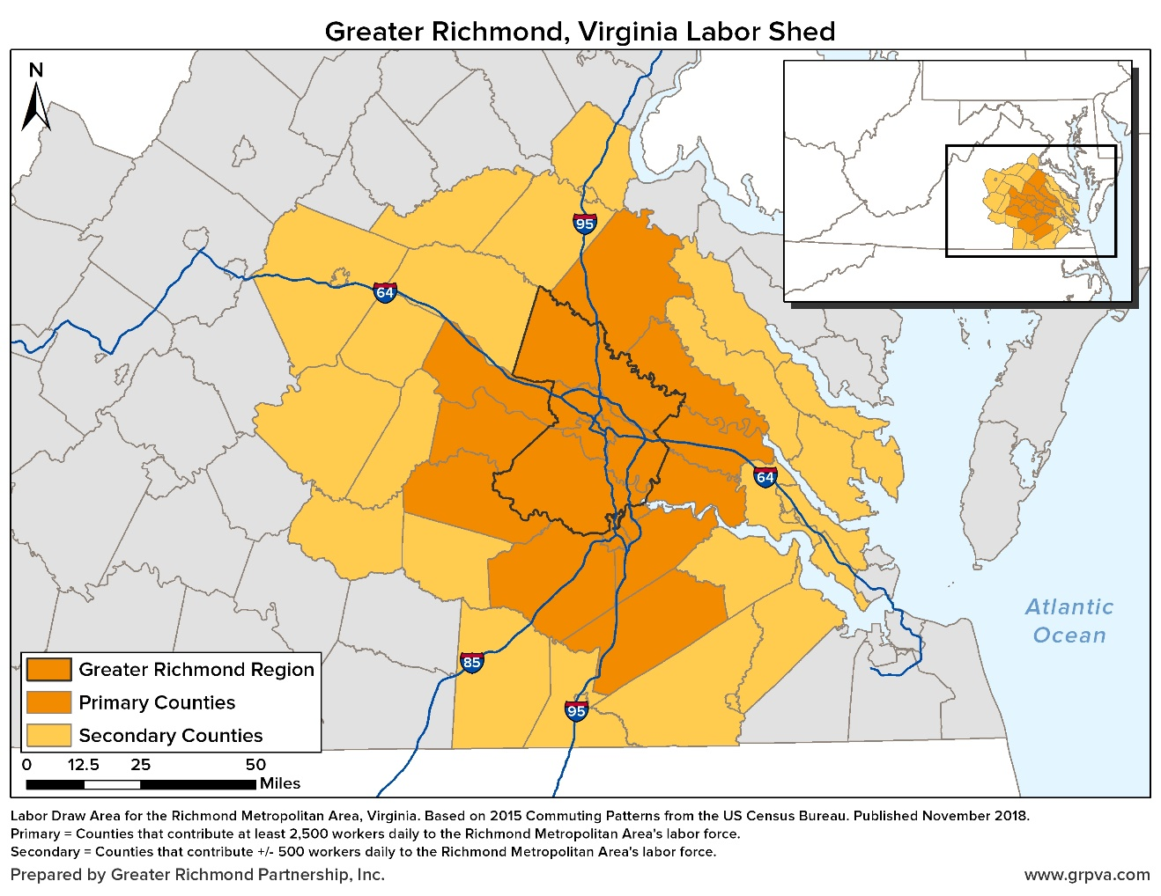

Updated July 2021

